Nischal Shrestha
Coventry University Student ID Number: 17103446
B.Sc. (Hons.) Computing, Softwarica College of IT and E-commerce, Coventry University
ST4003CEM Object Oriented Programming
Prabisha Khadka

- Write a program that prints Hello World! to the console. Save the program as Hello.java.

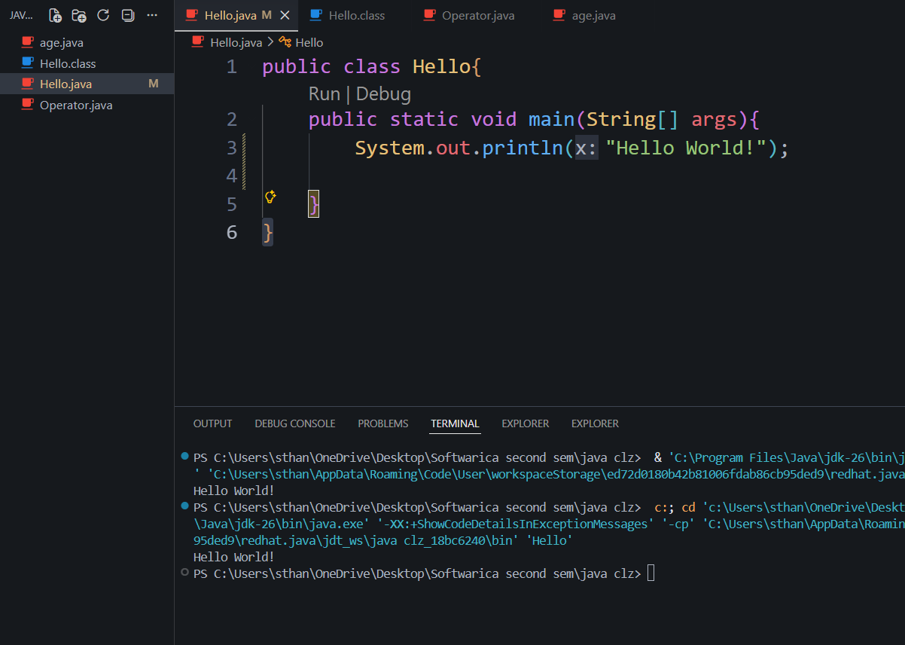

- Extend/Modify the above program to print two additional lines:
This is my first program
I am on module ST4003CEM
System.out.print (not println) and produces the same output.

- With println. ( it have \n)
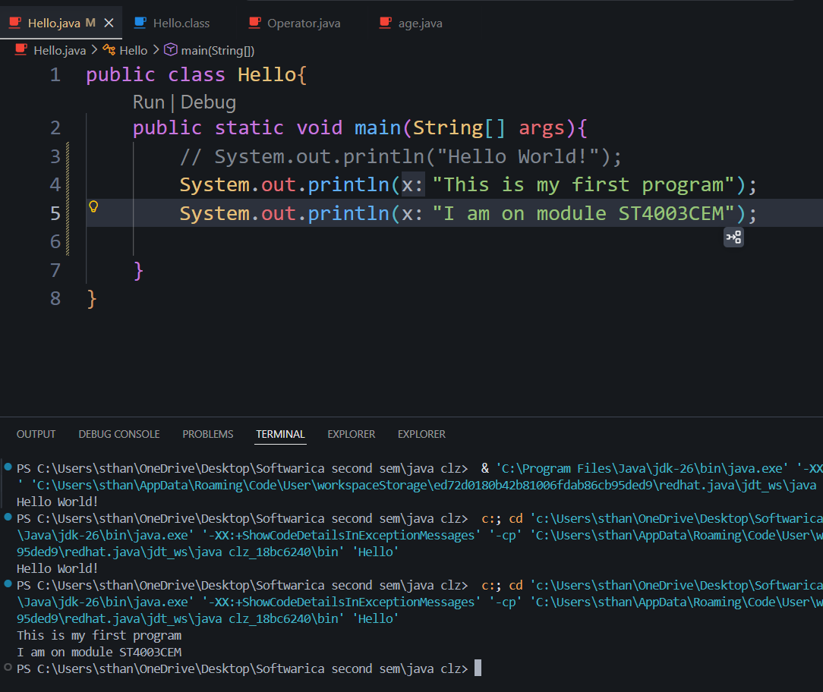

- With print ( it don’t have \n)
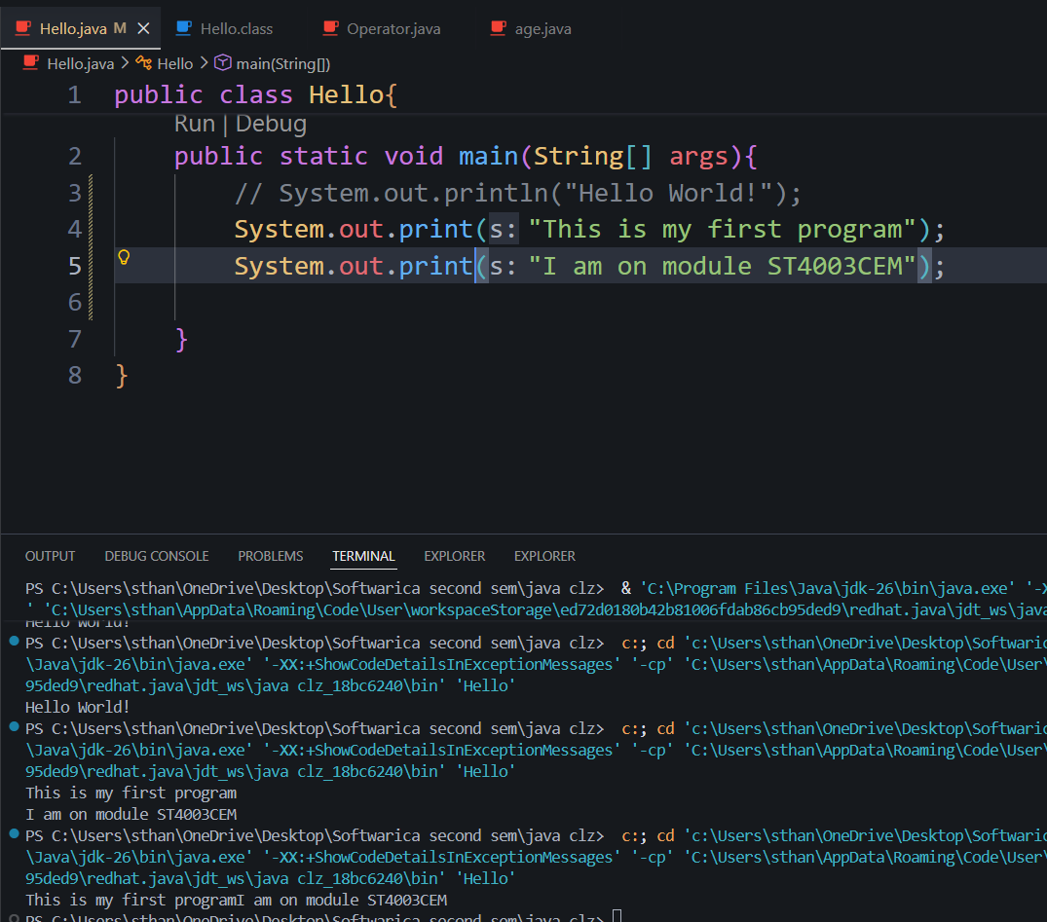

- Write a program that prints the following output:
A "quoted" String is
'much' better if you learn
the rules of "escape sequences."
Also, "" represents an empty
String. Don't forget: use \"
instead of " !
'' is not the same as "
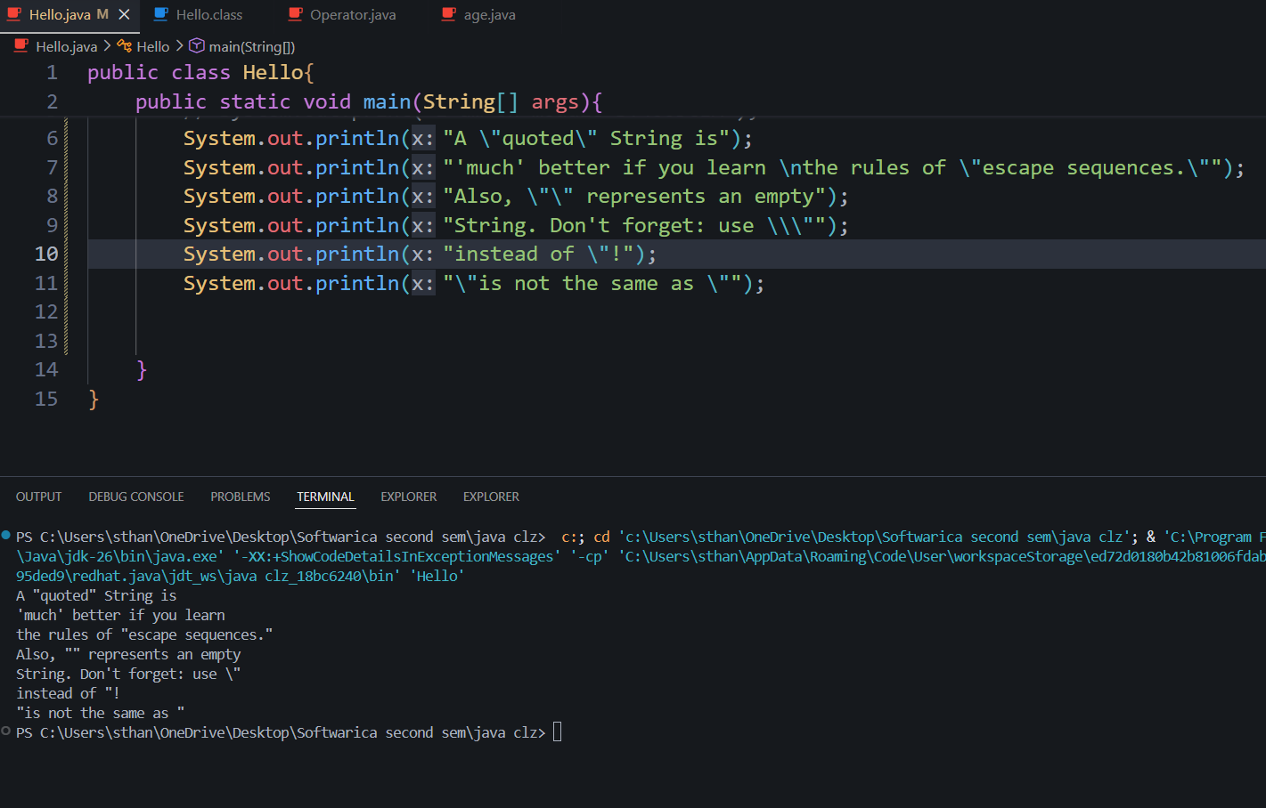

- WAP that prints the following pattern:
*
**
***
****
*****

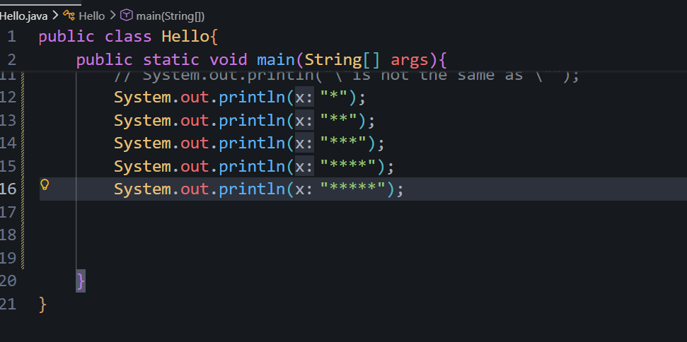

5. WAP prints the following pattern:
*********
*********
*********
*********
*********
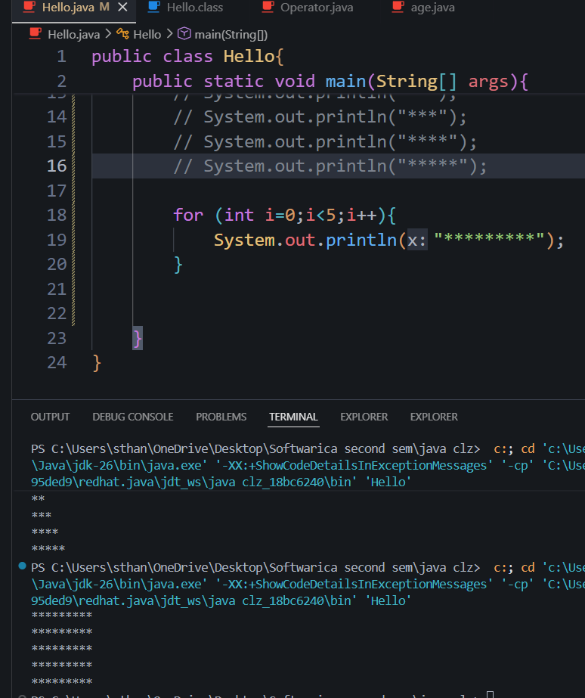

6. WAP that prints the following output:
A well-formed Java program has a main method with { and } braces.

A System.out.println statement has ( and ) and usually a String that starts and ends with a " character.
(But we type \" instead!)
What is the difference between
a ' and a "? Or between a " and a \"?

One is what we see when we're typing our program. The other is what appears on the "console."
